CS120 Practice Paper

Section 1 – Short-Answer Questions

1. Write out the output of the following lines
   1. printf(“|5, %d|”, 10);
   2. printf(“|%i , %f|”, 1, 3.0f);
   3. printf(“|%c, %u|”, 72, -1);
   4. printf(“|%3d|”, 10);
   5. printf(“|%-3d|”, 10);
   6. printf(“|%2d|”, 100.0f);
   7. printf(“|%\*d|”, 5, 20);
2. Write out the values of the following variables
   1. scanf(“(“%d”, &x); input: 10
   2. scanf(“%d, %d”, &x, &y); input: 3, 3
   3. scanf(“%f %c %d, &x, &y, &z); input: 10 51 1
   4. scanf(“%i, %f, %c, %lf, &x, &y, &z, &w); input: 4, 5.0f, ‘a’, 6.0
   5. scanf(“%i, %f, %c, %lf, &x, &y, &z, &w); input: 4 5.0f, ‘a’, 6.0
3. Which line(s) in the following code is/are invalid?

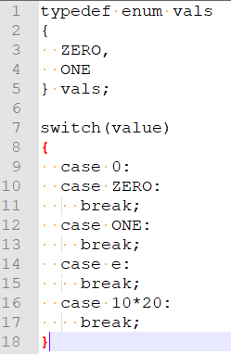

1. What is the print out of the following lines of code?

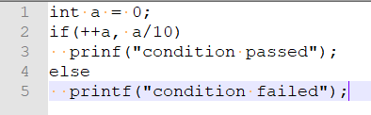

1. Change the following code to use a for loop.

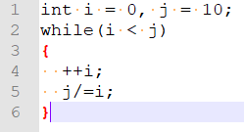

1. Change the following code to use a do-while loop.



1. Bracket the following expressions and determine if it compiles(C/NC).
   1. a \* b -- + c \* -- b
   2. x + ++y \* x - a + b
   3. ---x \* y + a -- b \* c++
   4. a - -b \* c / a + d++ - b
2. What is the output of the following bitwise operations?

Note: “^” is the xor operator

* 1. 1<<2
  2. 20>>1
  3. 10>>3
  4. (-1)<<1
  5. (-1)>>1
  6. (-5)>>1
  7. 10^8
  8. 4&5
  9. 9|12
  10. ~6

1. What is the difference between the member-of(dot) and the arrow operator? What is the arrow operator an alias of?
2. Write the following lines of code as a single line.

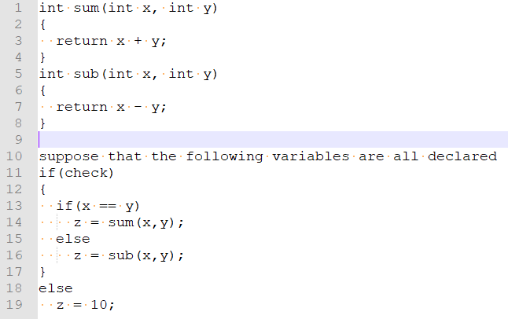

1. What does the subscript operator decays to?
2. Declare the following variables.
   1. i is an integer initialized to 0.
   2. f is a float initialized to 1.0f.
   3. pi is a pointer to an integer i.
   4. pci is a pointer to a constant integer initialized to a null pointer.
   5. cpi is a constant pointer that points to an integer i.
   6. cpci is a constant pointer that points to a constant integer.
   7. pS is a pointer to a struct Language.
3. Declare the following functions.
   1. Func is a function that takes in nothing and returns nothing.
   2. Func is a function that takes in 2 integer and returns an integer.
   3. Func is a function that takes in an array of integer and returns a integer.
   4. Func is a function that takes in a pointer to an array of floats and returns nothing.
   5. Func is a function that takes in a pointer that points to a float and returns a struct Vector.
4. Determine if the following lines compiles(C/NC). Put R if it will cause runtime error.
   1. int i = 10;
   2. const int ci = i;
   3. int\* pi = &i;
   4. ++\*pi--;
   5. ++\*--pi;
   6. ++(\*pi)--;
   7. const int\* cpi = &ci;
   8. ++cpi;
   9. free(pi);
   10. free(cpi);
5. Determine if the following parameters are inputs, outputs or both.
   1. void func(int i);
   2. void func(const int ci);
   3. void func(int\* pi);
   4. void func(const int\* cpi);
   5. void func(int const ci);
   6. void func(int const\* i);
   7. void func(int \* const i);
   8. void func(const int\* const i);
6. What is the output of the following recursive function?

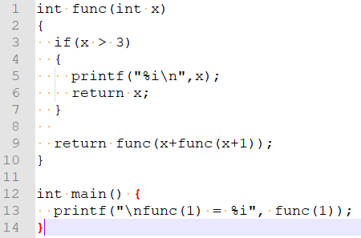

1. Initialize the following variables using memset to 0.
   1. char c;
   2. short s;
   3. int a[2];
   4. double\* pd = malloc(sizeof(double)\*3);
2. Write an example of a jaggered array. Draw a graph of the array and the memory layout.
3. What is the address of the following lines? Assume that the struct address is at 1000.

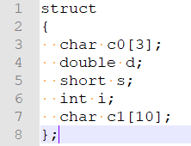

* 1. &c0[0]
  2. &d
  3. &s
  4. &c1[5]
  5. &d + 10
  6. &i – 20

1. What is a dangling pointer?
2. What would happen if there is a dangling pointer?
3. Write an example of a dangling pointer.
4. How many bytes of memory is lost in the following program?

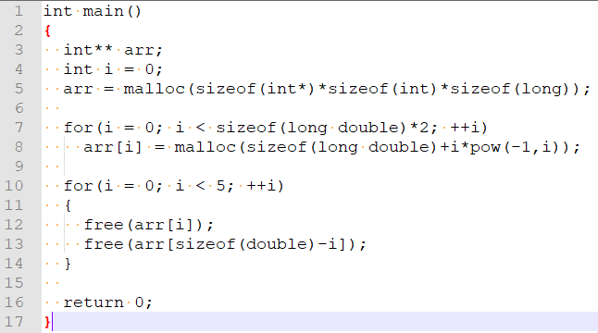

1. What is the memory layout of the following structs? Calculate the size of the struct. Assume that they start at address 1000.
   1. 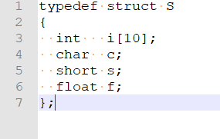
   2. 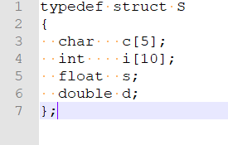
2. What is the advantage and disadvantage of arrays?
3. What is the advantage and disadvantage of using linked list?
4. What does the keyword word static means as a local variable?
5. What is the output of the following program?

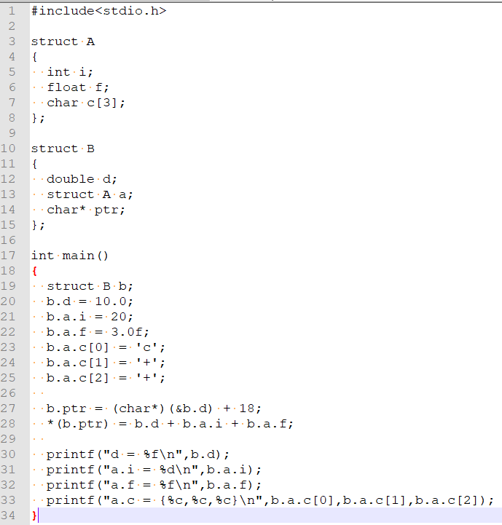

Section 2 – Programming Questions

1. Write a program that reads in any file, flip the contents backwards and write it back to the file. Only pointers are allowed.
2. Provide a function that takes in a pointer to an array of ints and the size of the array and return the highest count of the same element.

Hint: use 2d array to construct a table.

1. Write a program that simulates the behaviour of a human. The human is able to decide and act on the following actions: eat(), sleep(), exercise(), work() (when it is working time), cry(), (giveUpAndFlipTable)() (do nothing).

Bonus: include the use of function pointer

* 1. Declare the struct(s) needed for the program
  2. Write a function that decides the behaviour.
  3. Write a function that executes the selected action.
  4. Write a function that calls the function written in b and c.